ICS 103: Computer Programming in C
Handout-7 Topic: Control Structures (Repetition & Loop Statements)

Objective:

- To know use of increment operator ++, and decrement operator --
- To know syntax of while, do-while, for statements (loops).
- To know working of above loops with examples.

Use of increment operator ++, and decrement operator - - :

i++ means i=i+1;
i -- means i=i-1;

(For above statements in first step initial value of i will be assigned and after that value of i will be incremented or decremented).

++i means i=i+1 ;
-- i means i=i-1 ; (But in these, in first step initial value of i will be incremented or decremented and then value of i will be assigned ).

Examples:

#include<stdio.h>
main()
{
int i=2, r1 ;

r1=i++;

printf("Value of r1 is : %d", r1);
}

Sample Output:

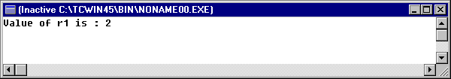

#include<stdio.h>
void main()
{
int i=2, r1 ;
r1 = ++i;
printf("Value of r1 is : %d", r1);
}

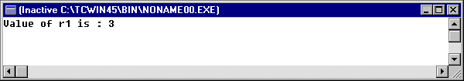

Looping Structures:

While statement:

Syntax: while (expression)
statement

A conditional loop is one whose continued execution depends on the value of a logical expression. In the above syntax as long as the expression is true the statement (or statements if enclosed within braces) is executed. When the expression evaluates to false the execution of the statement(s) stops and program continues with the other following statements.

Example:
Let number be an integer variable.

while (number > 100)
{
printf (“Enter a number\n”) ;
scanf (“%d”, &number) ;
}

In the above example, as long as the entered value of number is greater than 100 the loop continues to ask to enter a value for number. Once a number less than or equal to 100 is entered it stops asking. If in the beginning itself the value of number is less than or equal to 100, then the loop is not at all executed.

Note: In the while loop the expression is tested before the loop body statements are entered. So, if the expression is false in the beginning the loop body is never entered.

do…while statement :

Syntax: do
statement
while (expression) ;

Here, the expression is tested after the statement(s) are executed. So, even if the expression is false in the beginning the loop body is entered at least once. Here also like the while statement, as long as the expression is true the statement (or statements if enclosed within braces) is executed. When the expression evaluates to false the execution of the statement(s) stops and program continues with the other following statements.

Example:

The example of while loop can be written with do…while loop as :

do
{
printf (“Enter a number\n”) ;
scanf (“%d”, &number) ;
} while (number > 100) ;

In the above example, as long as the entered value of number is greater than 100 the loop continues to ask to enter a value for number. Once a number less than or equal to 100 is entered it stops asking.

Note: In the conditional looping using while and do…while the number of times the loop will be executed is not known at the start of the program.

for statement :

Syntax: for (expression 1; expression 2; expression 3)
Statement

In the iterative looping using for loop the number of times the loop will be executed is known at the start of the program. In the above syntax, the expression 1 is the initialization statement which assigns an initial value to the loop variable. The expression 2 is the testing expression where the loop variable value is checked. If it is true the loop body statement(s) are executed and if it is false the statements(s) are not executed. The expression 3 is usually an increment or decrement expression where the value of the loop variable is incremented or decremented.

Example:
for (count = 0 ; count < 10 ; count++)
{
printf (“Enter a value\n”) ;
scanf (“%d”, &num) ;
num = num + 10 ;
printf (“NUM = %d\n”, num) ;
}

In the above example the integer variable count is first assigned a value of 0, it is initialized. Then the value of count is checked if it is less than 10. If it is < 10 the loop body asks to enter a value for num. Then the value of count is incremented by 1 and again count is checked for less than 10. If it is true the loop body is again executed and then the count is incremented by 1 and checked for < 10. It keeps on doing like this until the count is >= 10. Then the loop stops. So, here the loop is executed 10 times.

Note: The increment operation is written as ++ and decrement operation is written as --. The increment increases the value by 1 and decrement decreases the value by 1.

Useful Solved Examples using different loops:

Example 1:
Print numbers ranging from 1 to n with their squares using for loop. The value of n is read by the program.

#include<stdio.h>
void main()
{
int num,square,limit;
printf("Please Input value of limit : ");
scanf("%d", &limit);

for (num=1; num < =limit; ++num)
{
square = num*num;
printf("%5d %5d\n", num, square);
} // end of for

} // end of main

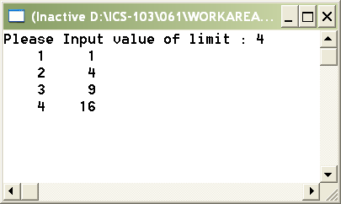

Example 2. :

/**********************************************************
Program Showing a Sentinel-Controlled for loop.
To Compute the sum of a list of exam scores and their aerage.
***********************************************************/

#include <stdio.h>
#define SENTINEL -99
int main(void)
{
int sum = 0, /* sum of scores input so far */
score, /* current score */
count=0; /* to count the scores */
double average;
printf("Enter first score (or %d to quit)> ", SENTINEL);
for(scanf("%d", &score); score != SENTINEL; scanf("%d", &score))
{
sum += score;
count++;
printf("Enter next score (%d to quit)> ", SENTINEL);
} // end of for loop
if(count>0) {
average=sum/count;
printf("\nSum of exam scores is %d\n", sum);
printf(“the average of exam scores is %f”,average);
}else
printf(“no scores entered”);

return (0);
} // end of main

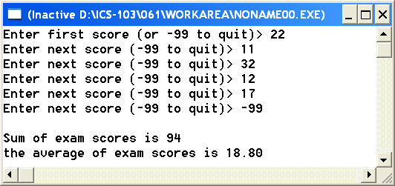

Example 3 :

while loop :

/*Conditional loop Using while Statement */

#include<stdio.h>
#define RIGHT_SIZE 10
void main()
{
int diameter;
printf("Please Input Balloon's diameter > ");
scanf("%d",&diameter);

while(diameter < RIGHT_SIZE)
{
printf("Keep blowing ! \n");

printf("Please Input new Balloon's diameter > ");
scanf("%d", &diameter);
} // end of while loop

printf("Stop blowing ! \n");
} // end of main

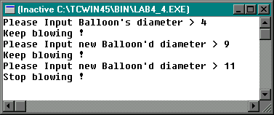

Example 4. :

do-while loop :

/* do-while loop */

#include<stdio.h>
void main()
{
int num;
do
{
printf("Please Input a number < 1 or >= 10 > ");
scanf("%d",&num);
} // end of do loop
while (num < 1 || num >=10) ;

printf("Dear , Sorry ! Your number is out of specified range in program");

} // end of main

Sample Output :

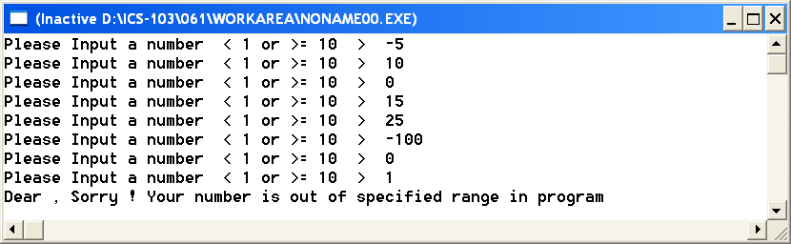

Example 5 :

Use of Increment and Decrement operators:

/* Explanation on Increment, Decrement operators */

#include<stdio.h>
void main()
{
int n, m, p, i = 3, j = 9;

n = ++i * --j;

printf("After the statement n = ++i * --j, n=%d i=%d j=%d\n", n, i, j);

m = i + j--;

printf("After the statement m = i + j--, m=%d i=%d j=%d\n",m ,i ,j);

p = i + j;

printf("After the statement p = i + j, p=%d i=%d j=%d\n", p, i, j);
} // end of main

Sample Output:

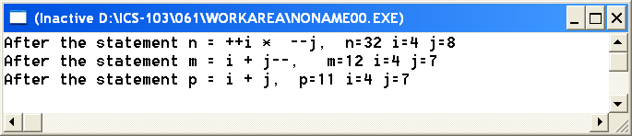

Example 6

What is the output of the following program

#include <stdio.h>
int main(void) {
int number, digits,sum;
digits=sum=0;
number=345;
do {
sum+=number%10;
number=number/10;
digits++;
printf("%d*%d\n",digits,sum);
}while(number>0);
return 0;
}

Example 7: Nested Loops
What is the output of the following program
#include<stdio.h>
void main(){
int i,j;
for (i=2; i<=7; i+=3) {
for (j=0;j <=i;j=j+3 )
printf("*");
printf("\n");
}
printf("i=%d\nj=%d",i,j);
}

Example 8:
What is the output of the following program
#include<stdio.h>
main( )
{
int j, x=0;
for (j=-2;j<=5;j=j+2) {
switch(j-1)
{
case 0 :
case -1 :

x += 1;

break;

case 1:
case 2:
case 3:

x += 2;
break;

default:
x += 3;
}
printf("x = %d\n", x);
}
}

